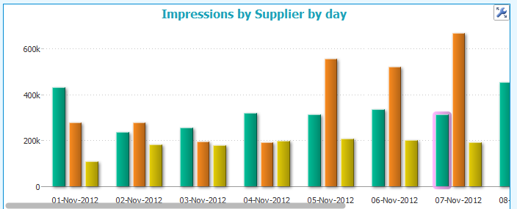
Scale in shown – data doesn’t fit within the screen
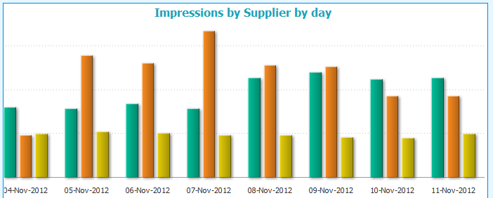
The last few days of data are shown but the axis/scale is missing on the left. Is it possible to lock it so it is visible even while scrolling?

