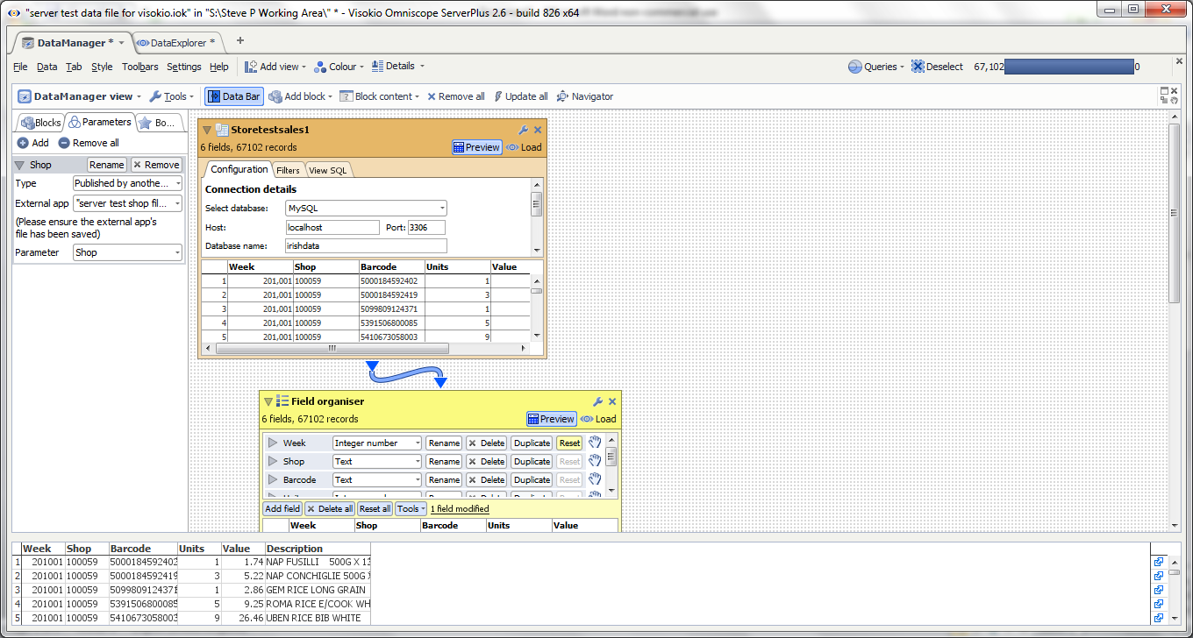
The file block is going to a MySQL table, using a parameter passed from another .iok file, to bring back matching records. All works OK...
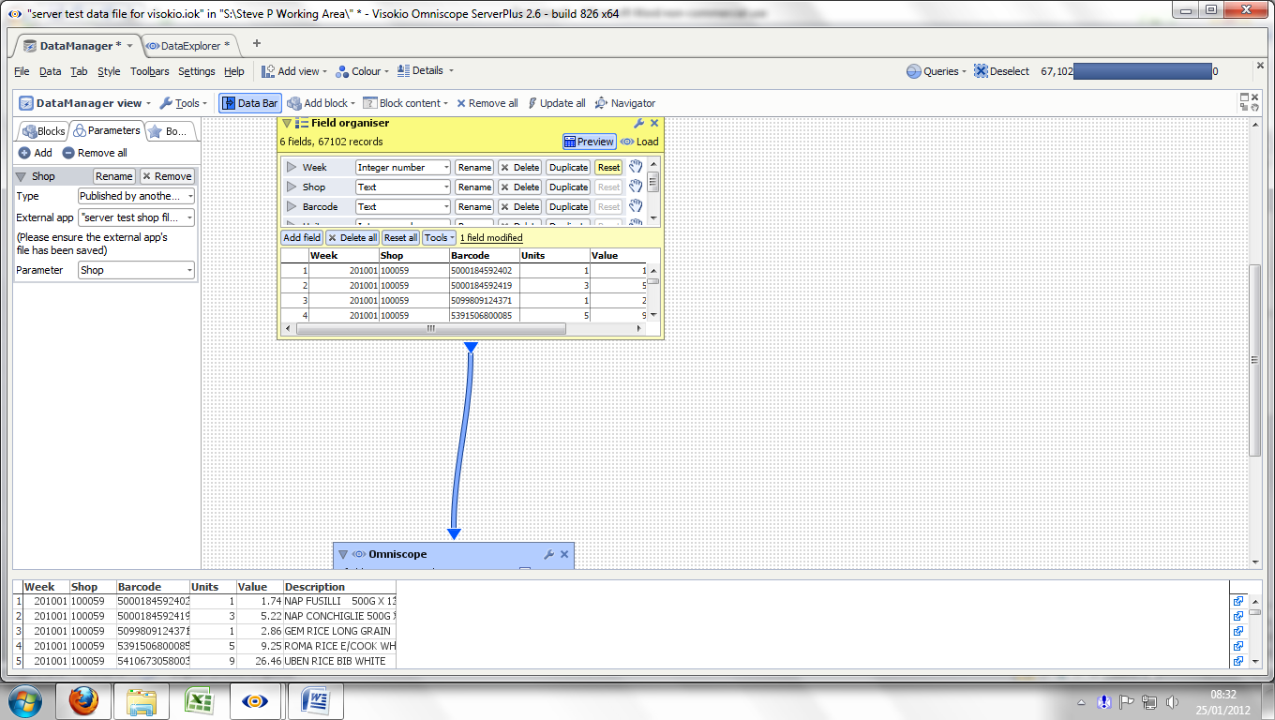
...until you scroll down the page...
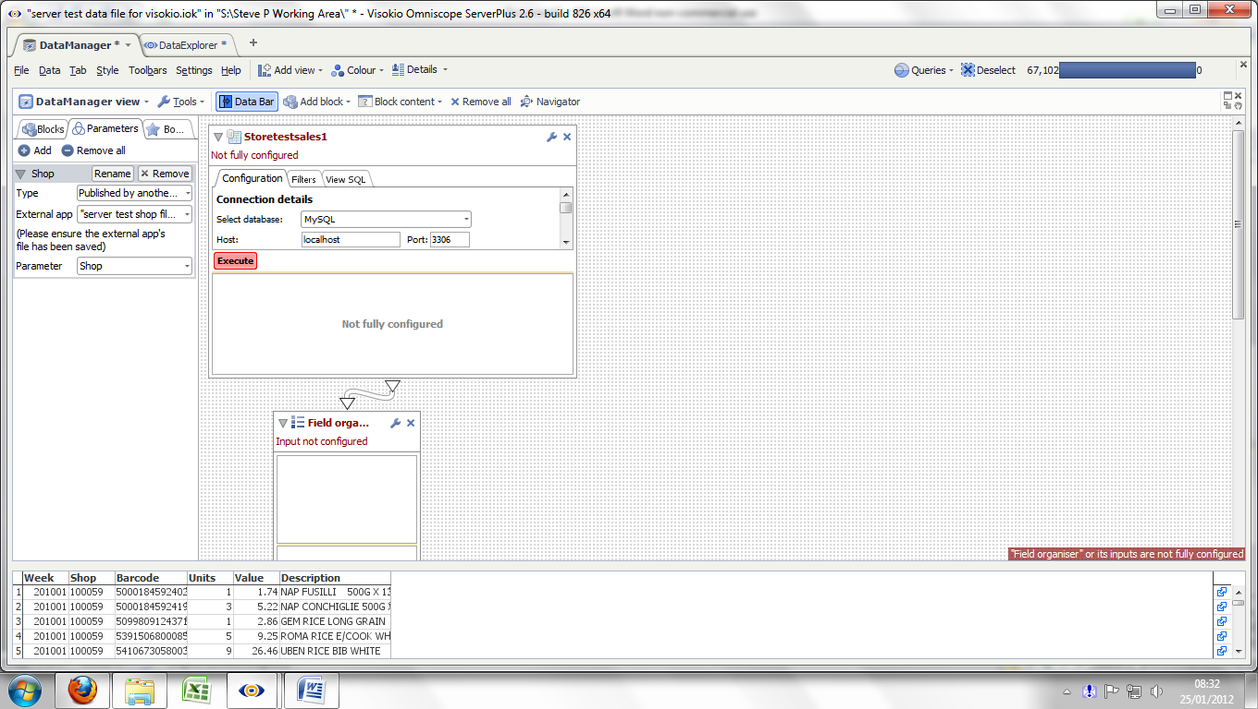
...and back up again. As you scroll back up, the File block changes to “not fully configured”. If you click on Execute it returns to the correct state.
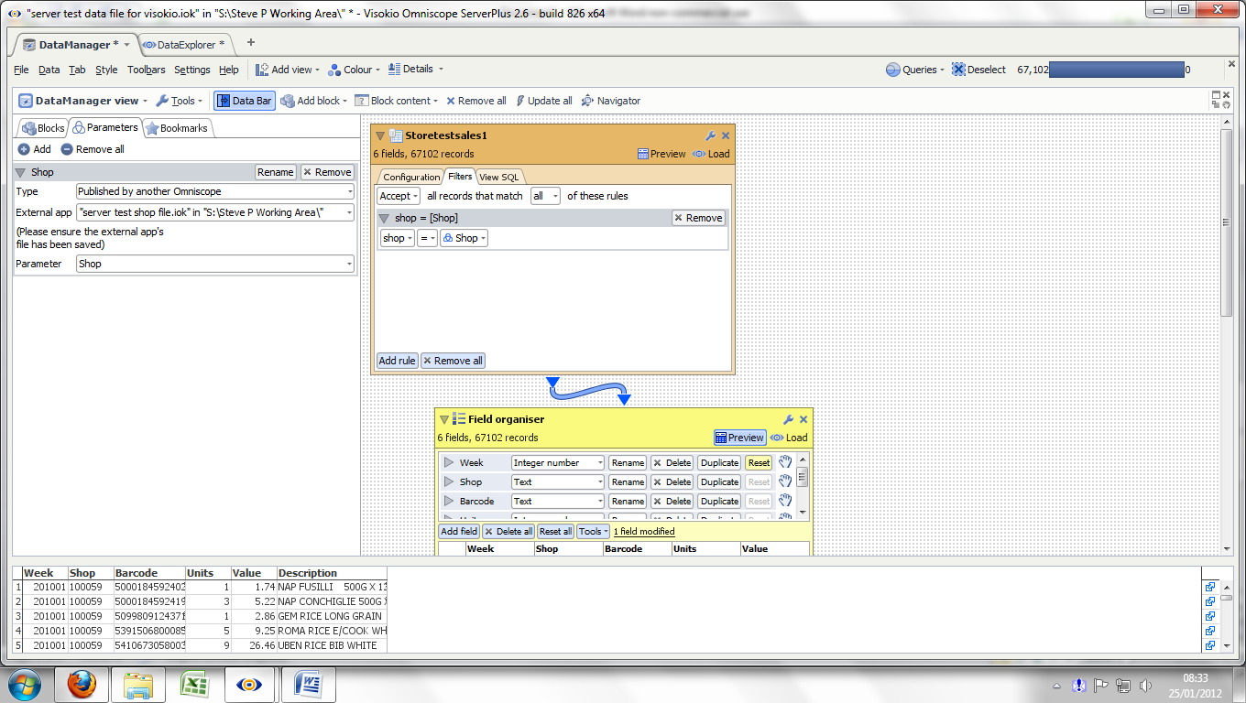
The detail of the parameter / filter settings are shown here
This is using the latest version of 2.6 build 826, 64bit.

