Figure 1: Original table
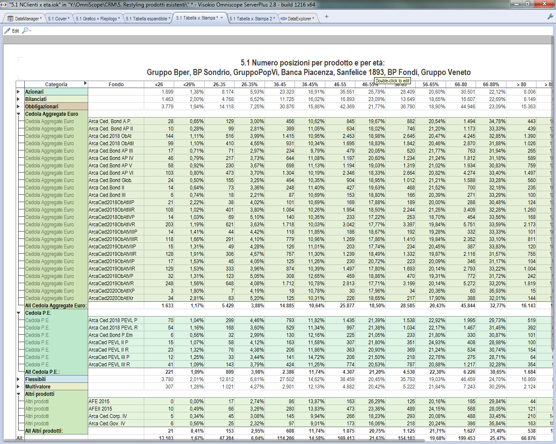

Figure 2: Copied table

Figure 3: Original table with original column order
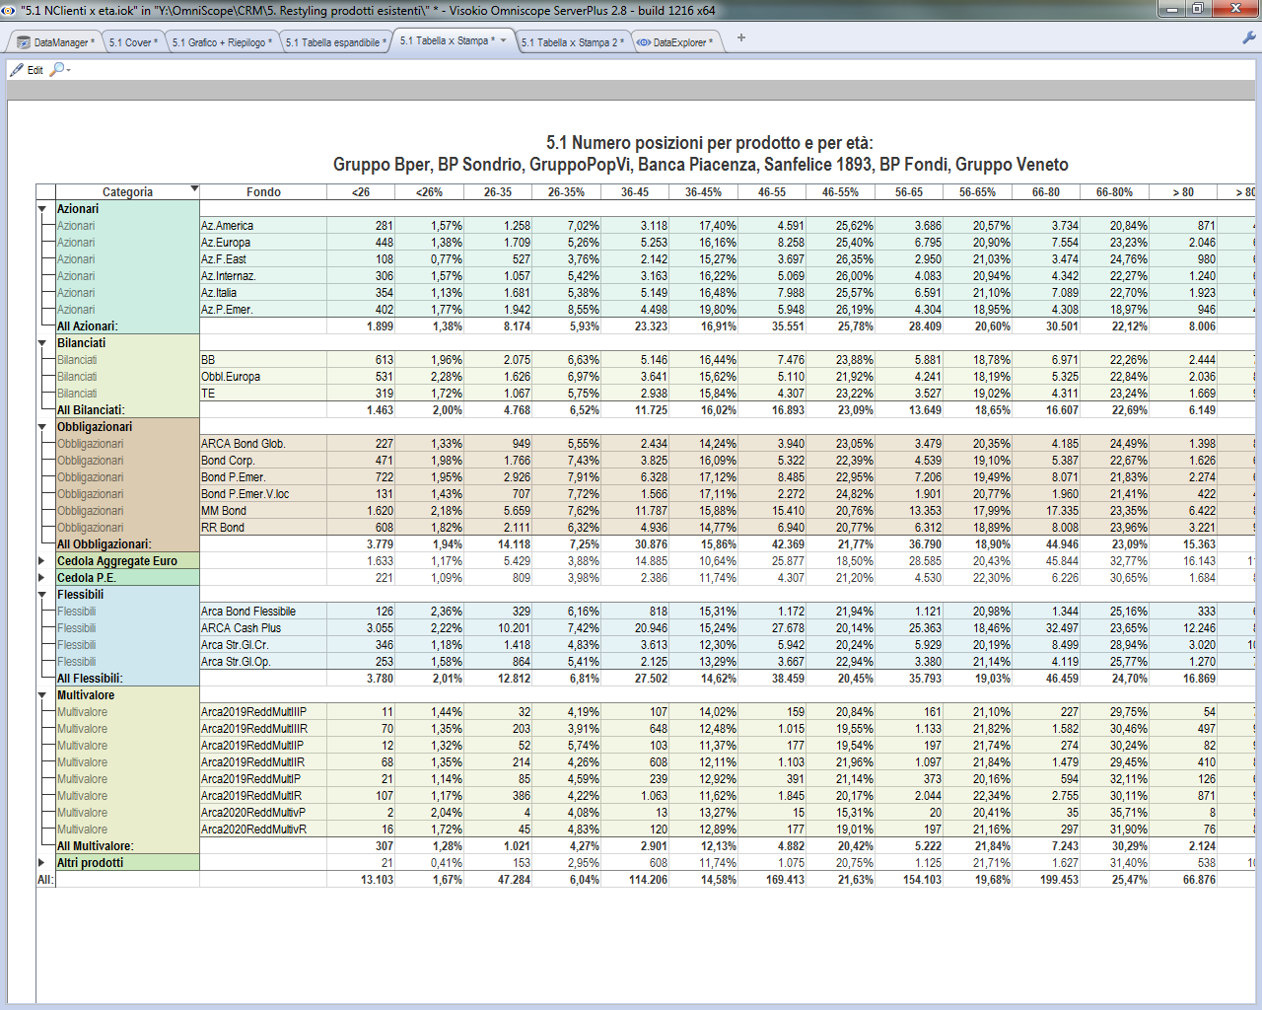

Figure 3: Copied table with modified column order (<26% column has been put before <26 column)
