Below is column of pivot view.
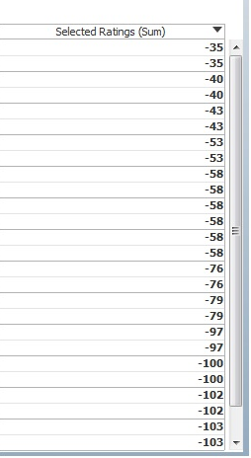

If in y-axis I put restriction for 5 distinct values say

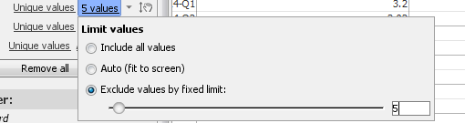

Column of selected rating has values:
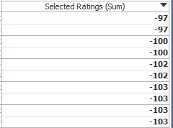

10 values in this column because the column (Say a) having restriction of 5 values has two same values of selected ratings for each.

As of now selection of 5 values is random. I want it to depend on selected ratings. Restriction of 5 will be on column a and data should be selected after ordering in selected rating.

My problem is, it is giving default values of ‘selected rating’. Can I restrict it to select minimum values? Ex: -35,-40,-43,-53,-58

