Current view is
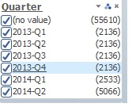
And it is working fine. Data is getting filtered according to the field.

Required view should be like

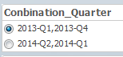

Can we create a filter with some options like above?

