Suppose in tab1 we have below data

If I select empname A in tab1.
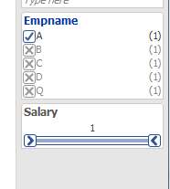

I want this A in tab2. For any change in selection tab1 value in tab2 should also change.

