Sample page from PDF produced directly opening the .iok file and pressing publish on the Data Manager output block.
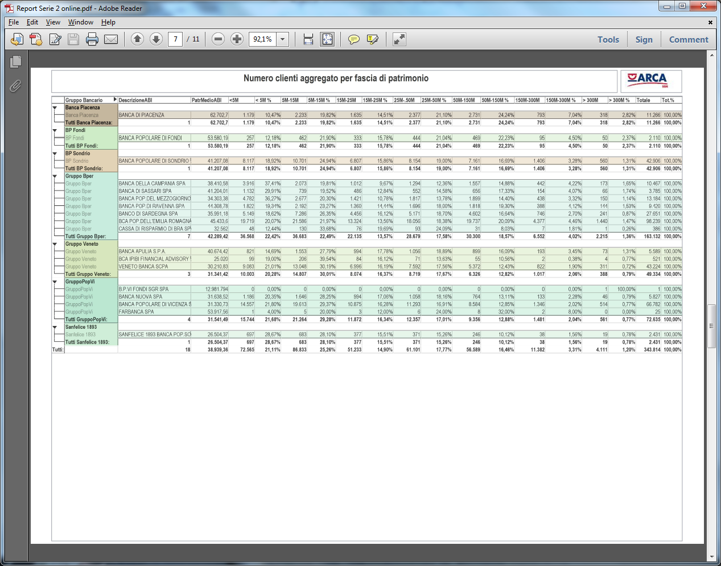

Sample page from PDF printed from scheduled process (table is not shown completely any more).
