Empty Data Manager after scheduling.
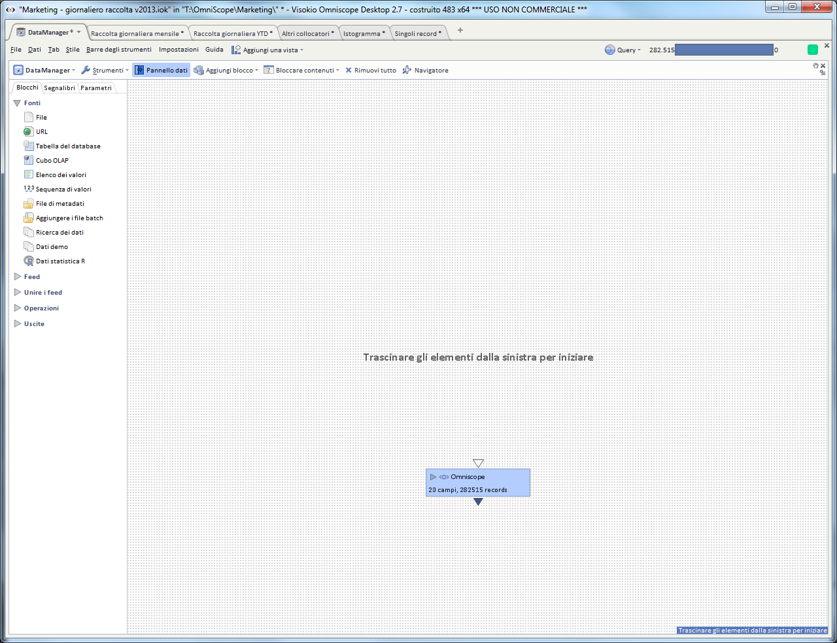
Original Data Manager:
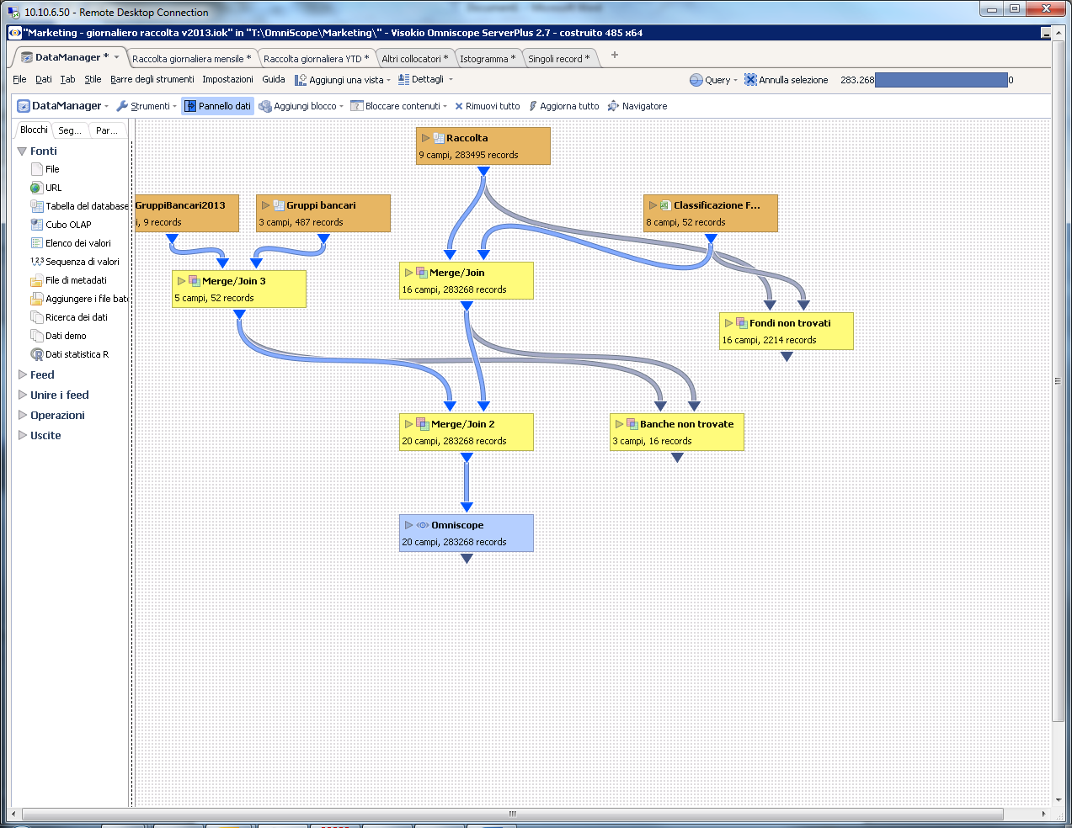
Old (not refreshed) data are still available in Omniscope:
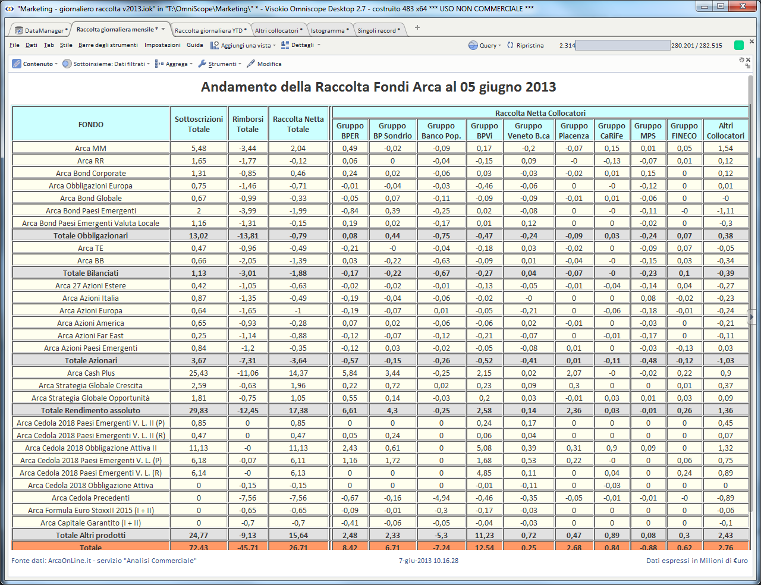
SCHEDULER LOG FILE:
2013.06.06 09:46:45.984 Detail: ...done in 16 min 46 sec
2013.06.06 09:46:45.984 debug: Sleeping 23 ora 13 min until 2013.06.07 09:00:00.090
2013.06.07 09:00:01.175 Info: Executing task "Aggiornamento FC - raccolta/massa giornaliera" (Catena di azioni, ogni giorno da 3-giu-2013 9.00, per sempre)...
2013.06.07 09:00:01.176 Detail: Task is 1.1 sec late
2013.06.07 09:00:01.176 debug: Launching process; command: "C:\Users\ufficio_ga\AppData\Local\Visokio Omniscope app\x64\bin\java.exe" -Xmx5800M -Djava.awt.headless=true -Dvisokio.winproxyenable="1" -Dvisokio.winproxyserver="172.16.33.12:8080" -Dvisokio.disableSystemProxies="true" -cp "Main.jar;plugins\InstalledExtras.jar;plugins\wrapper.jar;lib\activation.jar;plugins\bccrypto.jar;plugins\jtds-1.2.5.jar;plugins\jacob.jar;plugins\mediamind.jar;plugins\sap.jar;lib\mail.jar;plugins\transform.jar;plugins\gdata-analytics-2.1.jar;plugins\gdata-client-1.0.jar;plugins\gdata-spreadsheet-3.0.jar;plugins\google-collect-1.0-rc1.jar;plugins\gdata-core-1.0.jar;plugins\restfb-1.6.9.jar;plugins\jaxb-api.jar;plugins\commons-lang.jar;plugins\htmlparser.jar;lib\imap.jar;lib\pop3.jar;plugins\salesforce.jar;plugins\axis.jar;plugins\jaxrpc.jar;plugins\commons-discovery-0.2.jar;plugins\gson-1.7.1.jar;plugins\commons-httpclient-3.1.jar;plugins\commons-codec-1.3.jar;plugins\saaj.jar;plugins\wsdl4j-1.5.1.jar;plugins\xmpcore.jar;plugins\metadata-extractor.jar;plugins\javacup.jar;plugins\olap4j.jar;plugins\xercesImpl.jar;plugins\dom4j-1.6.1.jar;plugins\poi-3.7-20101029.jar;plugins\poi-ooxml-3.7-20101029.jar;plugins\poi-ooxml-schemas-3.7-20101029.jar;plugins\xmlbeans-2.3.0.jar;plugins\entagged.jar;plugins\atlas.jar;plugins\castor-0.9.3.21.jar;plugins\dartapi.jar;plugins\rome-1.0.jar;plugins\java-libpst.0.7.jar;plugins\engine-ie.jar;plugins\jsyntaxpane-0.9.5_jdk5.jar;plugins\jxbrowser-2.9.1.jar;plugins\log4j-1.2.15.jar;plugins\mdbdriver.jar;plugins\runtime.jar;plugins\slf4j-api-1.5.8.jar;plugins\slf4j-log4j12-1.5.8.jar;plugins\webReportDynamic.jar;plugins\webReportStatic.jar;plugins\winpack-3.8.2.jar;plugins\wsc.jar" com.visokio.ent.EntLaunch -streamAction
2013.06.07 09:00:01.197 debug: Created process
2013.06.07 09:00:01.200 debug: Starting outReader
2013.06.07 09:00:01.201 debug: Starting errReader
2013.06.07 09:00:01.201 debug: Starting kill thread with 3000 second timeout
2013.06.07 09:00:01.212 debug: Kill thread: polling
2013.06.07 09:00:01.213 debug: Kill thread: sleeping for 2999.988 seconds
2013.06.07 09:00:15.617 debug: Sent action
2013.06.07 09:00:15.618 debug: Waiting for action...
2013.06.07 09:02:58.095 debug: Waited for; code 0
2013.06.07 09:02:58.096 debug: Kill thread: polling
2013.06.07 09:02:58.096 debug: Kill thread: already finished
2013.06.07 09:02:58.097 debug: Joined readers
2013.06.07 09:02:58.097 Detail: Action generated output:

Executing action Catena di azioni...
Opening "\\10.10.5.90\decacli\OmniScope\Marketing\Marketing - giornaliero raccolta v2013.iok"
Saved to "\\10.10.5.90\decacli\OmniScope\Marketing\Marketing - giornaliero raccolta v2013.iok"
Opening "\\10.10.5.90\decacli\OmniScope\Marketing\Marketing - raccolta massa con funzione per il calcolo dei giorni lavorativi.iok"
Refreshed from "DataManager"
Saved to "\\10.10.5.90\decacli\OmniScope\Marketing\Marketing - raccolta massa con funzione per il calcolo dei giorni lavorativi.iok"
Executed chain: "Catena di azioni"
...done.

Scheduler configuration:
