PARETO

Understanding the Pareto Principle (The 80/20 Rule)
Originally, the Pareto Principle referred to the observation that 80% of Italy’s wealth belonged to only 20% of the population.
More generally, the Pareto Principle is the observation (not law) that most things in life are not distributed evenly. It can mean all of the following things:
- 20% of the input creates 80% of the result
- 20% of the workers produce 80% of the result
- 20% of the customers create 80% of the revenue
- 20% of the bugs cause 80% of the crashes
- 20% of the features cause 80% of the usage
- And on and on…
But be careful when using this idea! First, there’s a common misconception that the numbers 20 and 80 must add to 100 — they don’t!
20% of the workers could create 10% of the result. Or 50%. Or 80%. Or 99%, or even 100%. Think about it — in a group of 100 workers, 20 could do all the work while the other 80 goof off. In that case, 20% of the workers did 100% of the work. Remember that the 80/20 rule is a rough guide about typical distributions.
Also recognize that the numbers don’t have to be “20%” and “80%” exactly. The key point is that most things in life (effort, reward, output) are not distributed evenly – some contribute more than others.

Life Isn’t Fair
What does it mean when we say “things aren’t distributed evenly”? The key point is that each unit of work (or time) doesn’t contribute the same amount.
In a perfect world, every employee would contribute the same amount, every bug would be equally important, every feature would be equally loved by users. Planning would be so easy.
But that isn’t always the case:
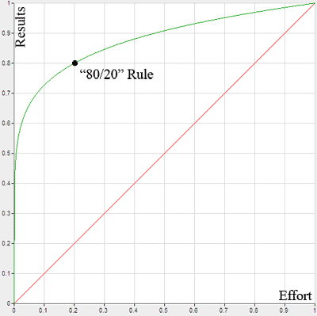
The 80/20 rule observes that most things have an unequal distribution. Out of 5 things, perhaps 1 will be “cool”. That cool thing/idea/person will result in majority of the impact of the group (the green line). We’d like life to be like the red line, where every piece contributes equally, but that doesn’t always happen.
Of course, this ratio can change. It could be 80/20, 90/10, or 90/20 (remember, the numbers don’t have to add to 100!).
The key point is that most things are not 1/1, where each unit of “input” (effort, time, labor) contributes exactly the same amount of output.

So Why Is This Useful?
The Pareto Principle helps you realize that the majority of results come from a minority of inputs. Knowing this, if…
20% of workers contribute 80% of results: Focus on rewarding these employees.
20% of bugs contribute 80% of crashes: Focus on fixing these bugs first.
20% of customers contribute 80% of revenue: Focus on satisfying these customers.
The examples go on. The point is to realize that you can often focus your effort on the 20% that makes a difference, instead of the 80% that doesn’t add much.
In economics terms, there is diminishing marginal benefit. This is related to the law of diminishing returns: each additional hour of effort, each extra worker is adding less “oomph” to the final result. By the end, you are spending lots of time on the minor details.

